65947 test document
User is able to create Case Template:
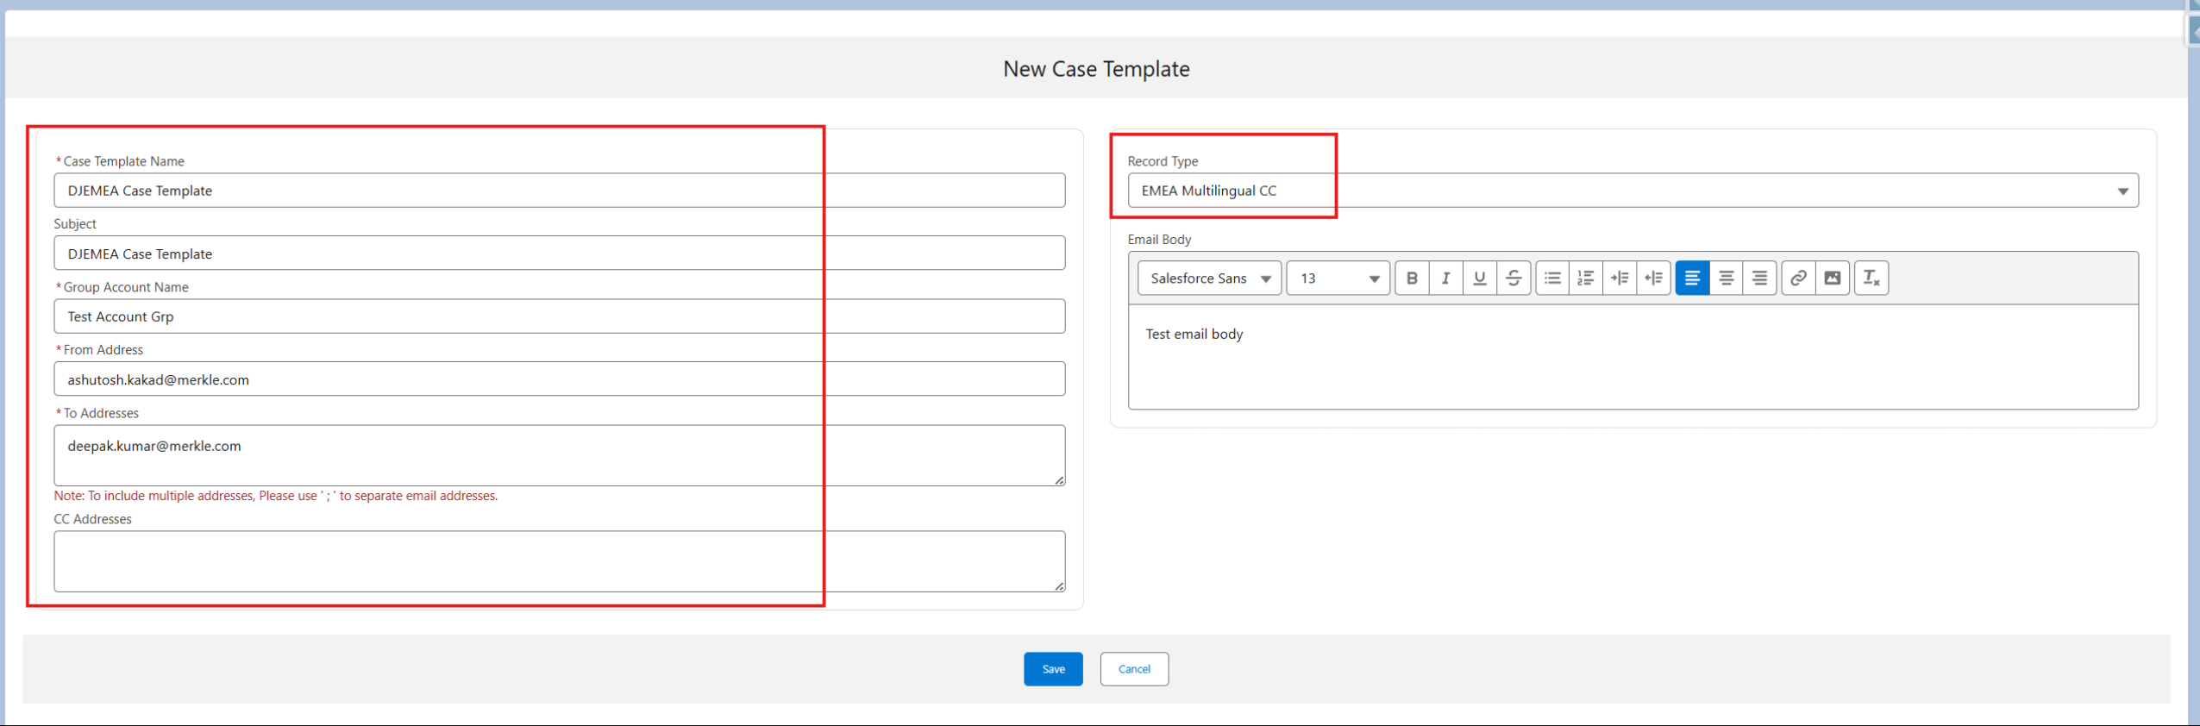
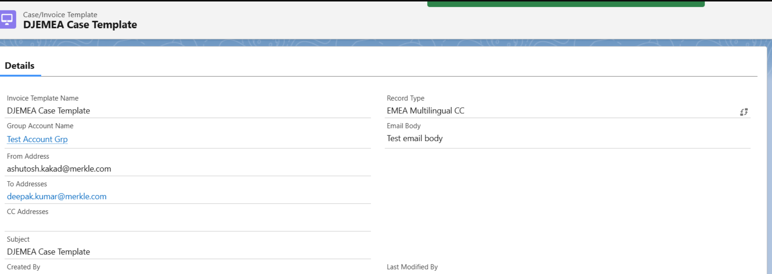
User is able to Initiate Case using the Template.
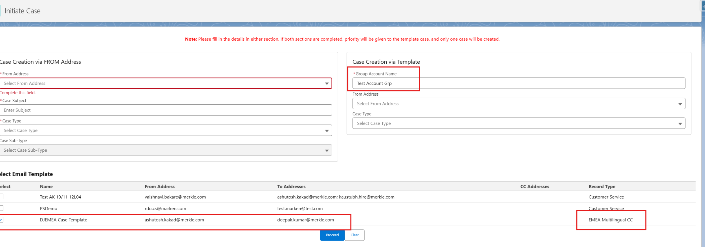
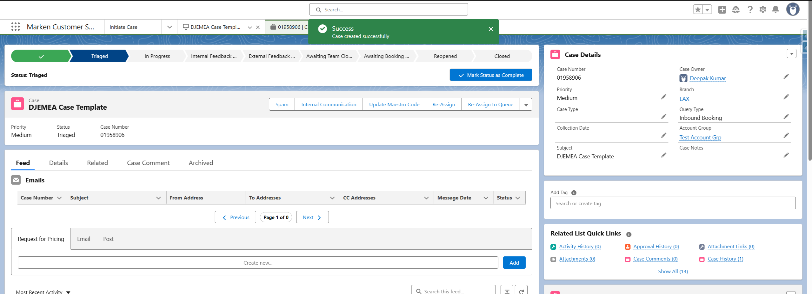
https://marken--markenqa.sandbox.lightning.force.com/lightning/r/Case/500ds000009cPOTAA2/view

